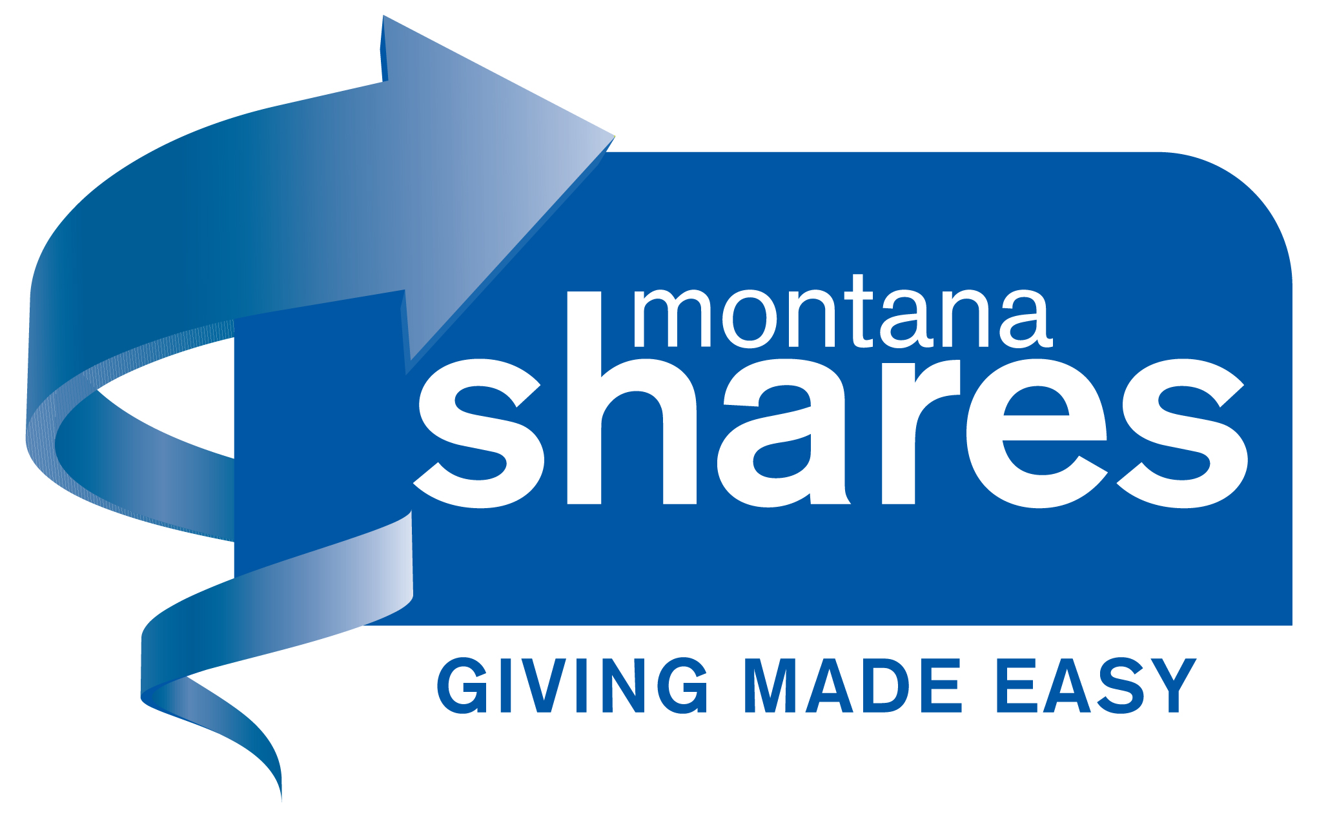

PO Box 883 Helena, MT 59624
406/442-2218
Email: shares@montanashares.org
www.montanashares.org

MONTANA SHARES CALENDAR
FOR ALL MEMBERS

2024

August Distribution checks mailed (#1 for 2023/2024 campaign).
August 23 Raffle prize MUST BE TURNED IN.
September 9 All raffle tickets and money must be turned in.
September 11 Fall ZOOM Membership meeting WEDNESDAY SEPT. 11TH, 9:00-11:00, ZOOM.
Raffle drawing held during membership meeting!
October Distribution checks mailed (#2 for 2023/2024 campaign).
Fall Campaign starts with ONLY check and credit card accepted

2025

January Distribution checks mailed (#3 for 2023/2024 campaign).
April/May Distribution checks mailed (FINAL for 2023/2024) (flexible, based on receipt of final
SECGC distribution)
Distribution of 2024/2025 cash/credit card only campaign

